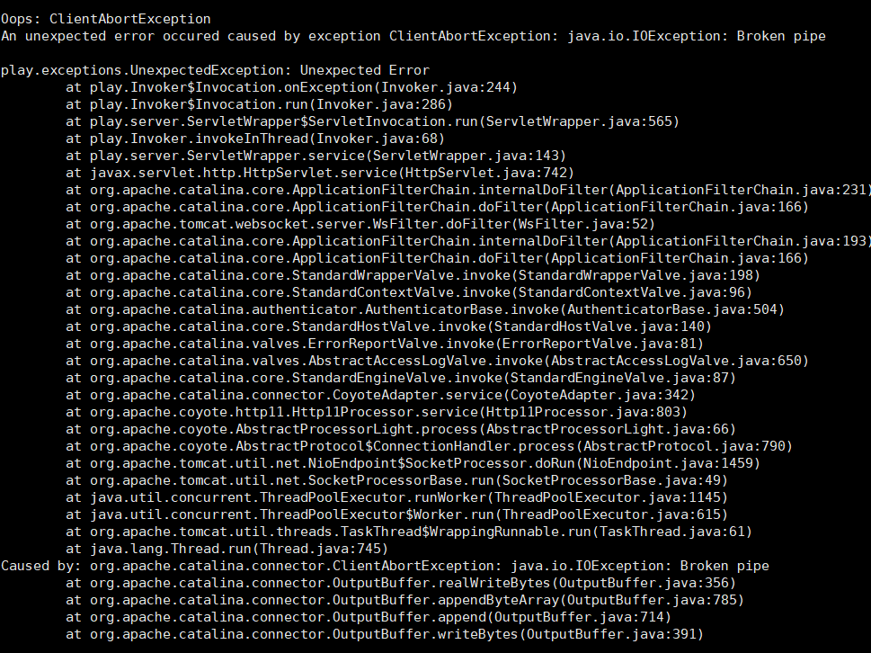

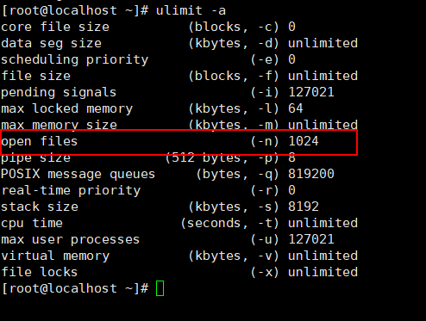

ulimit -a

netstat -n | awk '/^tcp/ {++state[$NF]} END {for(key in state) print key,"\t",state[key]}'

sysctl -a |grep keepalive